

O'ZBEKISTON RESPUBLIKASI

OLIY TA'LIM, FAN VA INOVATSIYALAR

VAZIRLIGI

MIRZO ULUGBEK NOMIDAGI

O ZBEKISTON MILLIY UNIVERSITETI

AMALIY MATEMATIKA VA INTELLEKTUAL

TEXNALOGIYALARI FAKULTETI

AMALIY MATEMATIKA

YO’NALISHI 2-BOSQICH TALABASI

UMAROV DADAXON

# MALAKAVIY AMALIYOT HISOBOTI

**Tekshirdi: Ro’zimatov J.**

**Topshirdi:Umarov D.**

* 1 Пример

Berilgan natural sondan katta bo‘lmagan barcha “*do‘st*” sonlar juftiligi chop etilsin (Ikkita natural son “*do‘st*” deyiladi, agarda ularning har biri ikkinchisining bo‘luvchilari (o‘zidan tashqari) yig‘indisiga teng bo‘lsa, masalan: 220 va 284 sonlari).

using System;

using System.Collections.Generic;

using System.Linq;

class Program

{

static void Main()

{

Console.Write("Birinchi sonni kiriting: ");

int son1 = int.Parse(Console.ReadLine());

Console.Write("Ikkinchi sonni kiriting: ");

int son2 = int.Parse(Console.ReadLine());

if (DostSonlar(son1, son2))

{

Console.WriteLine($"{son1} va {son2} sonlari dost sonlar.");

}

else

{

Console.WriteLine($"{son1} va {son2} sonlari dost sonlar emas.");

}

}

static List<int> BoLuvinchlar(int son)

{

List<int> boLuvinchlar = new List<int>();

for (int i = 1; i < son; i++)

{

if (son % i == 0)

{

boLuvinchlar.Add(i);

}

}

return boLuvinchlar;

}

static bool DostSonlar(int son1, int son2)

{

int boLuvinchlarSon1 = BoLuvinchlar(son1).Sum();

int boLuvinchlarSon2 = BoLuvinchlar(son2).Sum();

if (son1 < son2 && boLuvinchlarSon1 == son2 && boLuvinchlarSon2 == son1)

{

return true;

}

else

{

return false;

}

}

}

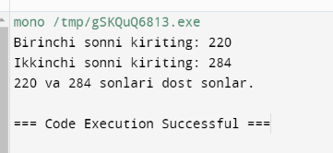

* 2 пример

Butun turdagi n-tartibli kvadrat matritsaning absolyut qiymati bo‘yicha eng katta elementlari toplisin. Shu elementlar joylashgan ustun va satrlarni o‘chirish orqali yangi matritsa qurilsin.

using System;

using System.Collections.Generic;

using System.Linq;

using System.Text;

using System.Threading.Tasks;

namespace ConsoleApplication3

class Program

{

static void Main()

{

int[,] matritsa = {

{ 1, -2, 3 },

{ 4, -5, 6 },

{ -7, 8, 9 }

};

var (katta, indeks) = KattaElement(matritsa);

Console.WriteLine("Eng katta element: " + katta);

int[,] yangiMatritsa = MatritsaOchir(matritsa, indeks);

Console.WriteLine("Yangi matritsa:");

PrintMatritsa(yangiMatritsa);

}

static (int, (int, int)) KattaElement(int[,] matritsa)

{

int katta = int.MinValue;

int n = matritsa.GetLength(0);

int m = matritsa.GetLength(1);

(int, int) indeks = (0, 0);

for (int i = 0; i < n; i++)

{

for (int j = 0; j < m; j++)

{

int absValue = Math.Abs(matritsa[i, j]);

if (absValue > katta)

{

katta = absValue;

indeks = (i, j);

}

}

}

return (katta, indeks);

}

static int[,] MatritsaOchir(int[,] matritsa, (int, int) indeks)

{

int satr = indeks.Item1;

int ustun = indeks.Item2;

int n = matritsa.GetLength(0);

int m = matritsa.GetLength(1);

int[,] yangiMatritsa = new int[n - 1, m - 1];

int newRow = 0, newCol = 0;

for (int i = 0; i < n; i++)

{

if (i == satr) continue;

newCol = 0;

for (int j = 0; j < m; j++)

{

if (j == ustun) continue;

yangiMatritsa[newRow, newCol] = matritsa[i, j];

newCol++;

}

newRow++;

}

return yangiMatritsa;

}

static void PrintMatritsa(int[,] matritsa)

{

int n = matritsa.GetLength(0);

int m = matritsa.GetLength(1);

for (int i = 0; i < n; i++)

{

for (int j = 0; j < m; j++)

{

Console.Write(matritsa[i, j] + " ");

}

Console.WriteLine();

}

}

}

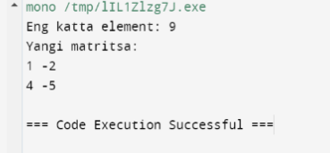

* 3 Пример

Natural p soni va 4-tartibli haqiqiy turdagi A,B va C kvadrat matritsalar berilgan.  hosil qilinsin

using System;

class Program

{

static void Main()

{

int p = 2; // Example value, can be any natural number

int[,] A = {

{ 1, 2, 3, 4 },

{ 5, 6, 7, 8 },

{ 9, 10, 11, 12 },

{ 13, 14, 15, 16 }

};

int[,] B = {

{ 16, 15, 14, 13 },

{ 12, 11, 10, 9 },

{ 8, 7, 6, 5 },

{ 4, 3, 2, 1 }

};

int[,] C = {

{ 1, 0, 0, 0 },

{ 0, 1, 0, 0 },

{ 0, 0, 1, 0 },

{ 0, 0, 0, 1 }

};

int[,] result = MultiplyMatrices(MultiplyMatrices(A, B), C);

int[,] finalResult = MatrixPower(result, p);

Console.WriteLine("Matrix (A * B * C)^p:");

PrintMatrix(finalResult);

}

static int[,] MultiplyMatrices(int[,] mat1, int[,] mat2)

{

int size = mat1.GetLength(0);

int[,] result = new int[size, size];

for (int i = 0; i < size; i++)

{

for (int j = 0; j < size; j++)

{

result[i, j] = 0;

for (int k = 0; k < size; k++)

{

result[i, j] += mat1[i, k] * mat2[k, j];

}

}

}

return result;

}

static int[,] MatrixPower(int[,] matrix, int power)

{

int size = matrix.GetLength(0);

int[,] result = matrix;

for (int i = 1; i < power; i++)

{

result = MultiplyMatrices(result, matrix);

}

return result;

}

static void PrintMatrix(int[,] matrix)

{

int rows = matrix.GetLength(0);

int cols = matrix.GetLength(1);

for (int i = 0; i < rows; i++)

{

for (int j = 0; j < cols; j++)

{

Console.Write(matrix[i, j] + "\t");

}

Console.WriteLine();

}

}

}

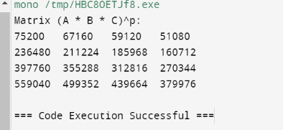

* 4 Пример

|  |
| --- |
| n ta butun elementli dinamik aniqlangan x vektorning elementlari o‘sish bo‘yicha tartiblangan. k o‘zgaruvchiga berilgan p soniga teng bo‘lgan x vektori elementining tartib nomeri berilsin, agarda bunday element bo‘lmasa, k o‘zgaruvchisiga -1 berilsin. |
| Masalani yechish uchun quyidagi ikkilik (binar) qidirish usuli qo‘llanilsin: p sonni vektor o‘rtasidagi yoki unga eng yaqin element bilan solishtiriladi; agar bu sonlar teng bo‘lsa qidirish to‘xtatiladi; agar p son elementdan kichik bo‘lsa, u holda p sonini vektorning chap yarmidan izlash kerak, aks holda o‘ng yarmidan; vektorning tanlangan yarmiga yuqoridagi algoritm qo‘llaniladi |  |

using System;

class Program

{

static void Main()

{

int[] x = { 1, 3, 5, 7, 9 };

int p = 6;

int index = TartibNomeri(x, p);

Console.WriteLine("P sonining tartib nomeri: " + index);

}

static int TartibNomeri(int[] x, int p)

{

int n = x.Length;

if (Array.Exists(x, element => element == p))

{

return Array.IndexOf(x, p);

}

else if (p < x[0] || p > x[n - 1])

{

return -1;

}

else

{

int left = 0;

int right = n - 1;

while (left <= right)

{

int mid = (left + right) / 2;

if (x[mid] == p)

{

return mid;

}

else if (x[mid] < p)

{

left = mid + 1;

}

else

{

right = mid - 1;

}

}

if (left < n && Math.Abs(x[left] - p) < Math.Abs(x[right] - p))

{

return left + 1;

}

else

{

return right + 1;

}

}

}

}

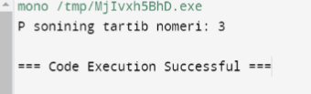

* 5 Пример

const int n=60;

char Jumla[n];

Berilgan gap(Jumla)dagi har bir so‘zning birinchi harfi bosh harfga almashtirilsin.

using System;

class Program

{

static void Main()

{

Console.WriteLine("Gapni kiriting:");

string gap = Console.ReadLine();

string natija = BoshHarfAlmashtir(gap);

Console.WriteLine("Natija: " + natija);

}

static string BoshHarfAlmashtir(string gap)

{

string[] words = gap.Split();

for (int i = 0; i < words.Length; i++)

{

if (!string.IsNullOrWhiteSpace(words[i]))

{

words[i] = "_" + words[i].Substring(1);

}

}

return string.Join(" ", words);

}

}  
  
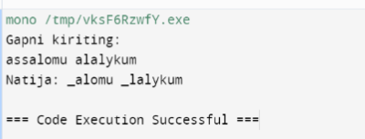

* 6 Пример

5 ta har xil natural son berilgan. Bu sonlarni barcha o‘rin almashish holatlari chop qilinsin.

using System;

using System.Collections.Generic;

using System.Linq;

class Program

{

static void Main()

{

int[] sonlar = { 1, 2, 3, 4, 5 };

List<int[]> almashuvlar = OrinAlmashish(sonlar);

Console.WriteLine("Barcha o'rin almashuvlar:");

foreach (var almashuv in almashuvlar)

{

Console.WriteLine(string.Join(", ", almashuv));

}

}

static List<int[]> OrinAlmashish(int[] sonlar)

{

List<int[]> natija = new List<int[]>();

Permute(sonlar, 0, natija);

return natija;

}

static void Permute(int[] arr, int k, List<int[]> natija)

{

if (k == arr.Length)

{

natija.Add(arr.ToArray());

}

else

{

for (int i = k; i < arr.Length; i++)

{

Swap(ref arr[i], ref arr[k]);

Permute(arr, k + 1, natija);

Swap(ref arr[i], ref arr[k]);

}

}

}

static void Swap(ref int a, ref int b)

{

int temp = a;

a = b;

b = temp;

}

}

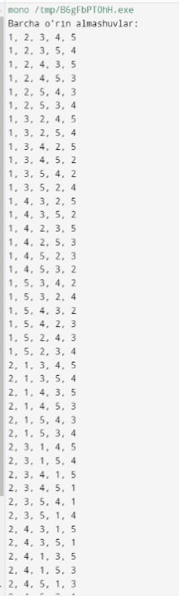 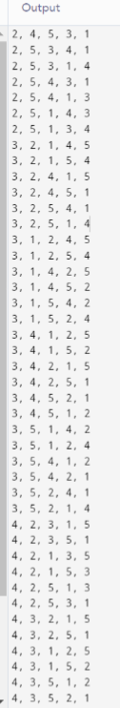 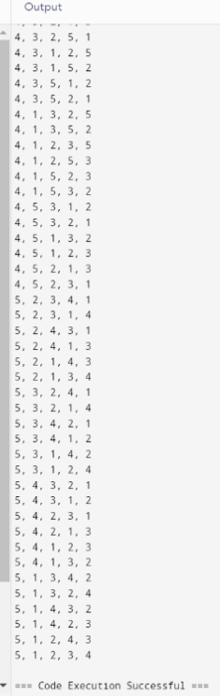

* 7 Пример

Butun sonlar juftligi bilan berilgan ratsional sonlar ustida amal bajaruvchi RATSIONAL sinfi aniqlansin. Sinf obyektlari massivini yaratilsin va sinfning do‘st funksiyalari yordamida quyidagi masalalar yechilsin:

using System;

class RATSIONAL

{

public int x;

public int y;

public RATSIONAL(int x, int y)

{

this.x = x;

this.y = y;

}

public bool Tenglik(RATSIONAL other)

{

return this.x * other.y == other.x * this.y;

}

public RATSIONAL Yigindisi(RATSIONAL other)

{

int newX = this.x * other.y + other.x * this.y;

int newY = this.y * other.y;

return new RATSIONAL(newX, newY);

}

static void Main()

{

RATSIONAL a = new RATSIONAL(3, 4);

RATSIONAL b = new RATSIONAL(6, 8);

Console.WriteLine("a va b tengmi? " + a.Tenglik(b));

RATSIONAL r = a.Yigindisi(b);

Console.WriteLine("a va b yig'indisi: " + r.x + "/" + r.y);

}

}

